- Mean density (number/m³) of adult Acartia spp. in high salinity water (>6 ppt) by month and year. Line colors denote Water Year Types: Wet (blue), Below Normal (pink), Dry (orange), Critical (Red). Data from the IEP Zooplankton Study.

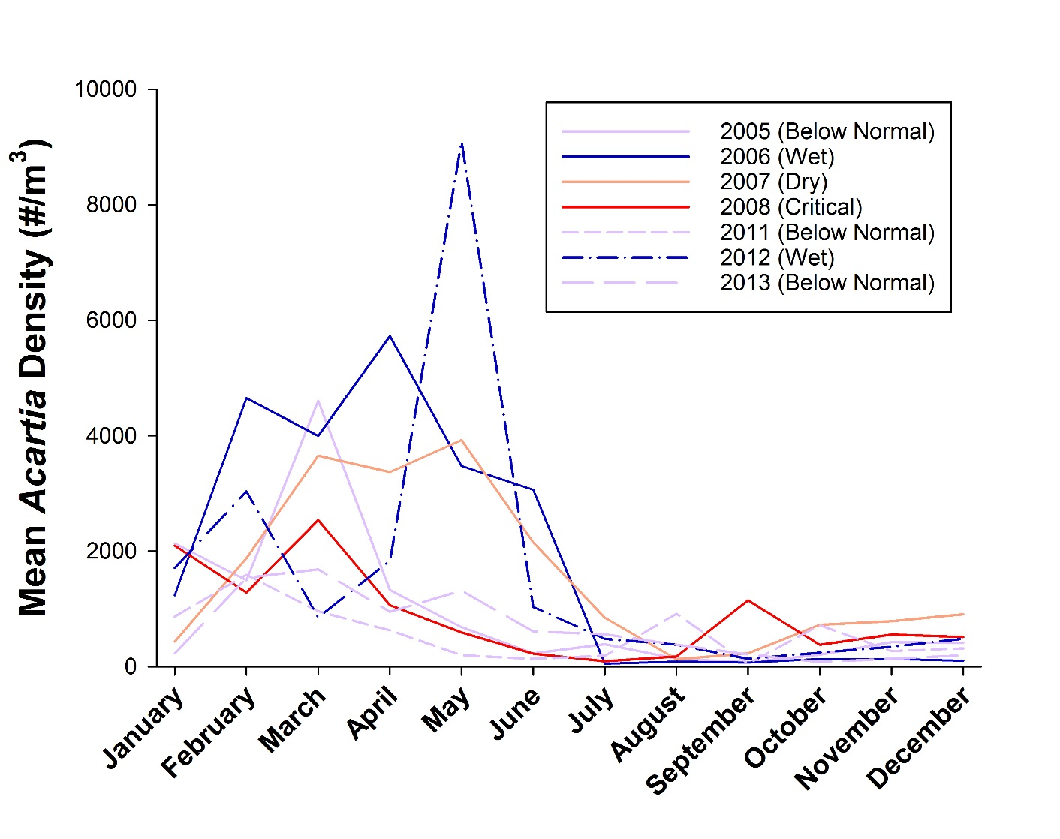

- Density (number/m³) of adult Pseudodiaptomus marinus in high salinity water (>6 ppt) by month and year. Line colors denote Water Year Types: Wet (blue), Below Normal (pink), Dry (orange), Critical (Red). Data from the IEP Zooplankton Study.

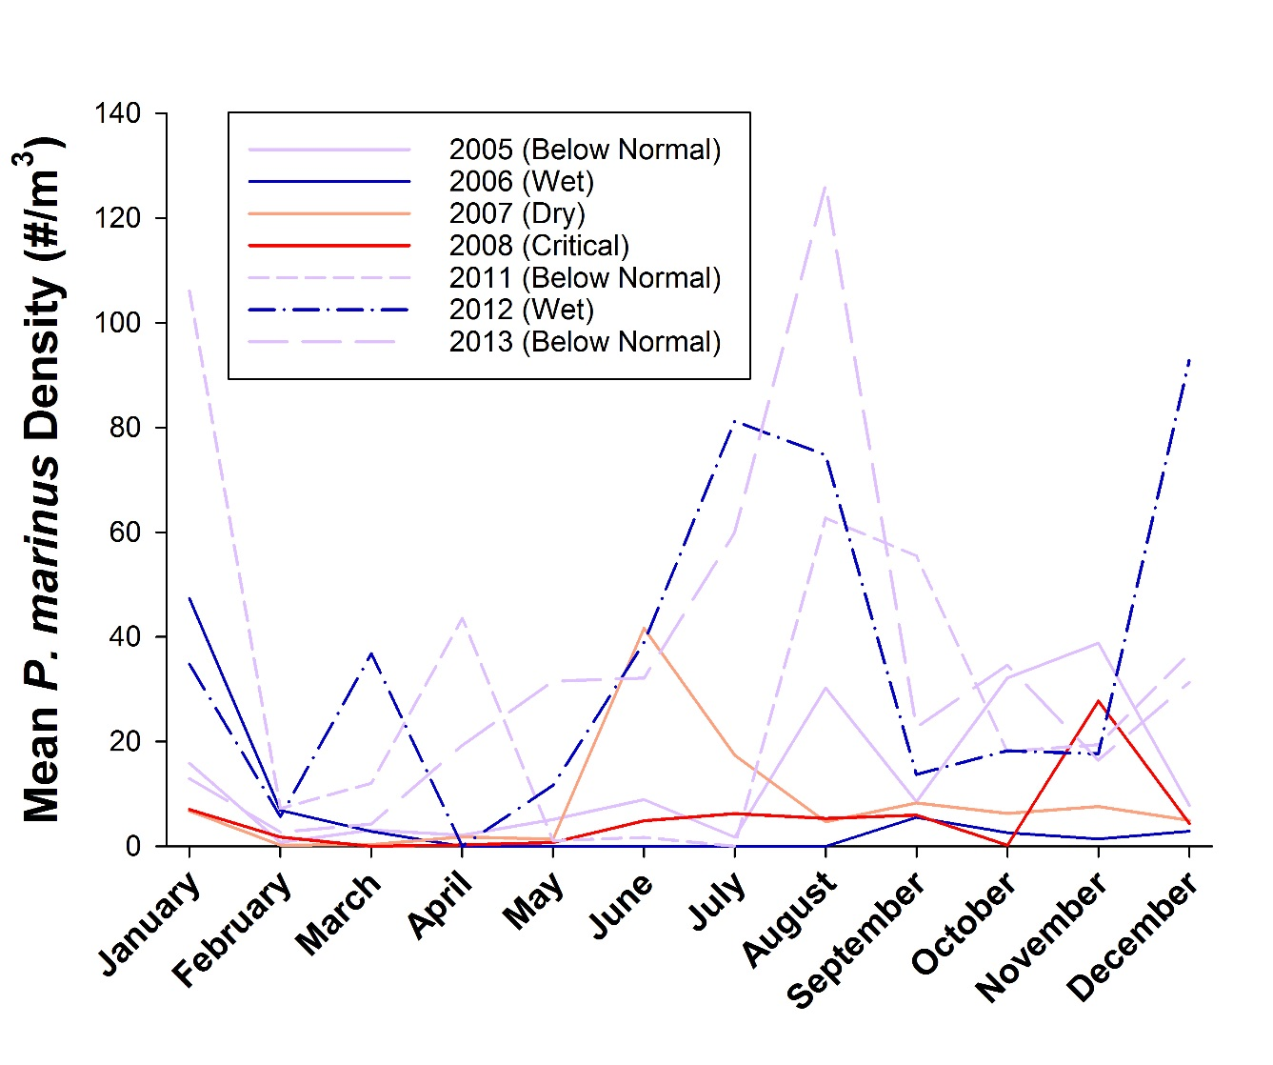

- Mean density (number/m³) of adult Eurytemora affinis by month and year for three salinity ranges. Each month 16 stations were sampled across all salinity ranges. Line colors denote Water Year Types: Wet (blue), Below Normal (pink), Dry (orange), Critical (Red). Data from the IEP Zooplankton Study index stations and the Delta Smelt Synthesis Report. Note the different Y-axis scales.

- Mean density (number/m³) of adult Pseudodiaptomus forbesi by month and year for three salinity ranges. Each month 16 stations were sampled across all salinity ranges. Line colors denote Water Year Types: Wet (blue), Below Normal (pink), Dry (orange), Critical (Red). Data from the IEP Zooplankton Study index stations and the Delta Smelt Synthesis Report. Note the different Y-axis scales.

- Mean density (number/m³) of adult Limnoithona spp. by month and year for three salinity ranges. Each month 16 stations were sampled across all salinity ranges. Line colors denote Water Year Types: Wet (blue), Below Normal (pink), Dry (orange), Critical (Red). Data from the IEP Zooplankton Study index stations and the Delta Smelt Synthesis Report Note the different Y-axis scales.

- Density (number/m³) of all mysid shrimp taxa by month and year for three salinity ranges. Each month 16 stations were sampled across all salinity ranges. Line colors denote Water Year Types: Wet (blue), Below Normal (pink), Dry (orange), Critical (Red). Data from the IEP Zooplankton Study index stations and the Delta Smelt Synthesis Report. Note the different Y-axis scales.

- Density (number/m³) of amphipod taxa by month.

- Diet composition (by %W) of larval Longfin Smelt and Pacific Herring (A) and Longfin Smelt and Prickly Sculpin (B) in February and March 2013 in the SFE. Sample size above each bar.

- Contribution (by percent weight) of main prey types to the diets of larval (<25 mm fork length) longfin in two wet (2005/2006) and two dry years (2007/2008) in San Pablo Bay, Napa River, Suisun Bay, Suisun Marsh, and the West Delta. Number of stomachs examined are shown above the columns.

- Contribution (by percent weight) of main prey types to the diets of young juvenile (25-45 mm fork length) longfin in two wet (2005/2006) and two dry years (2007/2008) in A) San Pablo Bay, B) Napa River, C) Suisun Bay, D) Suisun Marsh, and E) the West Delta. Number of stomachs examined are shown above the columns.

- Diet composition by %W, %N, and %FO of juvenile Longfin Smelt (August to December) in Suisun (2006: N=38, 2011: N=50) and San Pablo Bays (2006: N=64, 2011: N=69).

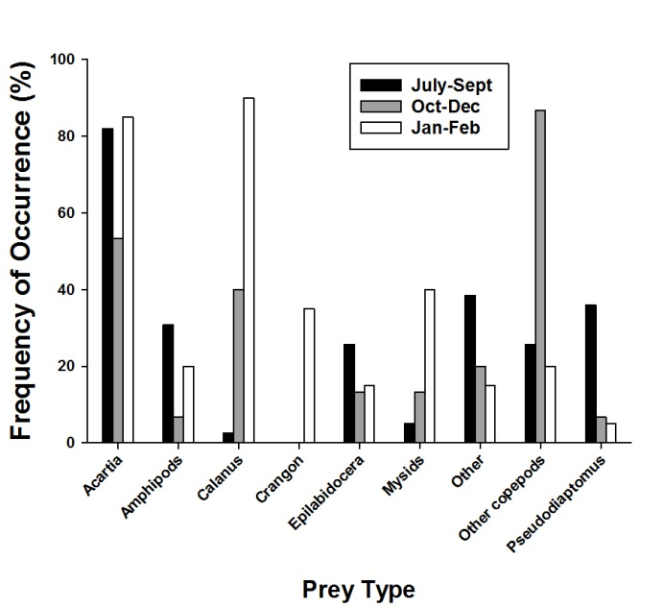
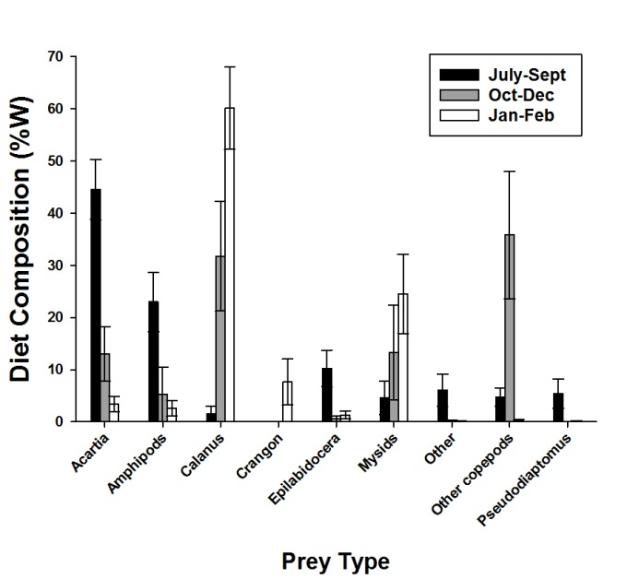
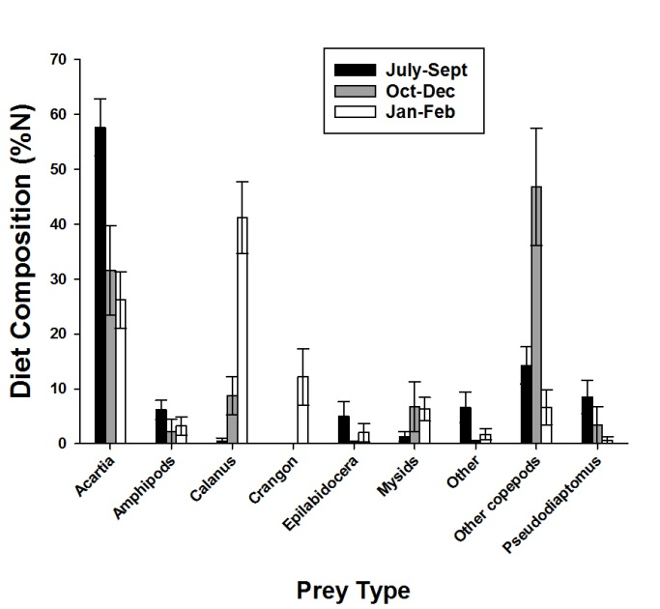
- Diet composition by %W, %N, and %FO of juvenile Longfin Smelt in summer (July-September, N=40) and winter (October-December, N=15) of 2011 and age 1+ longfin (January-February, N=20) of 2012 in the Central Bay.

- Diet composition by %W, %N, and %FO of juvenile Longfin Smelt in the Central Bay in summer (July-September) from 2005-2008. Sample size is given above each bar.
- Diet composition by %W, %N, and %FO of age 1+ Longfin Smelt in Napa River and Suisun Marsh (January 2007) and Sac River, Suisun Bay, and San Pablo Bay (January and February 2012).

